Extra notes:

[#post_1](https://www.facebook.com/hashtag/post_1?source=feed_text)  
[#Wilson](https://www.facebook.com/hashtag/wilson?source=feed_text)'s_Theorem

Wilson's theorem say that if P is a prime , then (p-1)! +1 is completely divisible by p

i.e. (p-1)! mod p=p-1  
example-   
find remainder when  
96! is divided by 97  
Now 97 is a prime number so  
96! mod 97=(97-1)! mod 97=96

● (p-1)! mod p=p-1

● (p-2)! mod p=1

● (p-3)! mod p=(p-1)/2

● (p-4)! mod p=k when prime is of form 6k-1 & it will be (p-k) if prime is form of 6k+1

[#post_2](https://www.facebook.com/hashtag/post_2?source=feed_text&story_id=397130624068098)  
[#must_know](https://www.facebook.com/hashtag/must_know?source=feed_text&story_id=397130624068098)  
a^n – b^n is always divisible by (a-b)

a^n – b^n is divisible by a+b , whenever n = even no.

a^n + b^n is always divisible by (a+b), when n = odd no

Remainder when 10^3+11^3+12^3+13^3 is divided by 46 is ?

0.

Find the remainder when x^10 is divided by (x^2 - 3x + 2)

OA: 1023x-1022  
x^10= (x-1)(x-2)P(x)+ax+b   
put x=1  
1=a+b  
put x=2   
1024 = 2a+b   
from both eqns , a=1023 b=-1022 so 1023x-1022

ind the remainder when 1^39 + 2^39 + 3^39 + 4^39 + ... + 12^39 is divided by 39.

a. 0   
b. 1   
c. 12   
d. 38

sum ( 1+2+3+4+...+12) = 78.

rem with 78 is zero.

Find the remainder when 32^33^34 is divided by 11.

Its Wednesday today. What DAY it will be " 3^51 " days from today?

Remainder when 7^7^7^7^7^7^7.......infinity is divided by 13?

oa: 6

98! MOD 101

Find the remainder when the below number is divided by 11.  
12345678910111213141516...979899.

39th one

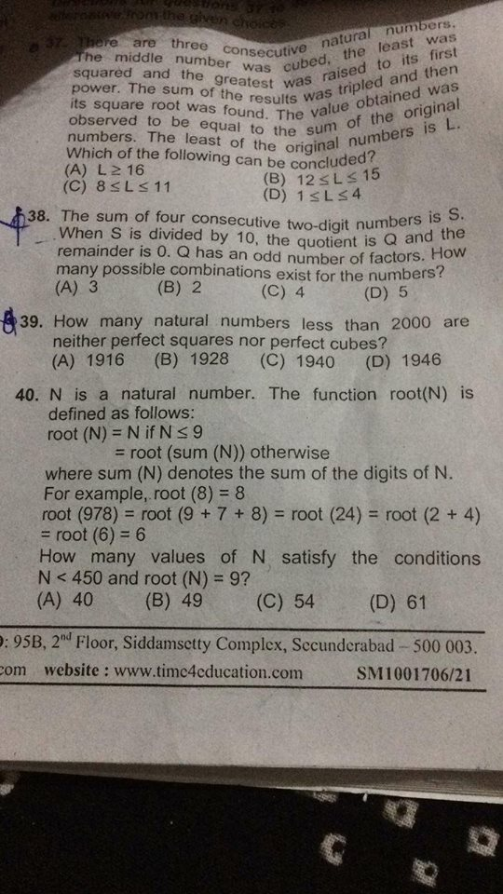

x < 2000

Perfect squares : x^2 < 2000

x < sqrt(2000)

x < 44 so 1-44

perfect cubes: x^3 < cuberoot(2000)

x < 12 so 1 - 12

common in both is x^6 (repeated twice hence removing once)

x^6 < sixthroot(2000)

x < 3

so total number 44 + 12 - 3 = 53

and 1 is neither perfect square not perfectr cube

so final number = 53+1

final answers = 2000 - 54 = 1946

I am getting 1947, d is probably the answer.  
2000-{Number of perfect squares + Number of perfect cubes - Numbers of the form a^6}  
2000-{44+12-3}

N=12^1 + 12^2 +..... +12^100.  
Find the remainder when N is divided by 7.

bhai thoda long method h but i could approach it this way only :  
12^1 mod 7 = 5  
12^2 mod 7 = 4  
12^3 mod 7 = 6  
12^4 mod 7 = 2  
12^5 mod 7 = 3  
12^6 mod 7 = 1  
After this, this cycle will repeat ALWAYS because Euler of 7 is 6. And 12^7 ki power ho jayegi 7mod6 = 1, 12^8 ki 8mod6 = 2 and so on...so it'll repeat.  
Till 12^96, 16 times repeat kregi ye cycle.  
So sum ho jayega (5+4+6+2+3+1)*16 = 21*16 to ye to direct divide ho jayega 7 s.  
Bachenge 12^97,12^98,12^99 and 12^100. Ye denge remainders as 5,4,6 and 2 respectively, so (5+4+6+2) mod 7 = 17 mod 7 = 3